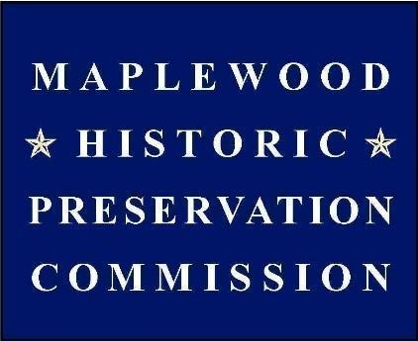 | Maplewood Historic Preservation Commission  Maplewood Municipal Building and ZOOM  October 16, 2024, 8:00 PM

AGENDA

OPMA & Roll Call

Approval of Minutes
- July and September

Public Comment

Applications and Demolition Reviews
- No hearings
- 13-15 Collinwood Rd demolition application research draft
- 11 Oakview Avenue
- 77 Durand Road

Township Projects
- Village Redevelopment Zone

Grants and Grant Projects
- Woodland Preservation Plan
- Preservation Element
- Next CLG grant round

Designations and Surveys
- Village District signage

Homeowner Research and Outreach
- Local History Room status

Membership
- Carla LaBianca’s seat is still open

Misc. and New Business
- Revised application form

